DEMONSTARTING HTML ASSERTION

It captures errros and warnings of test script execution.

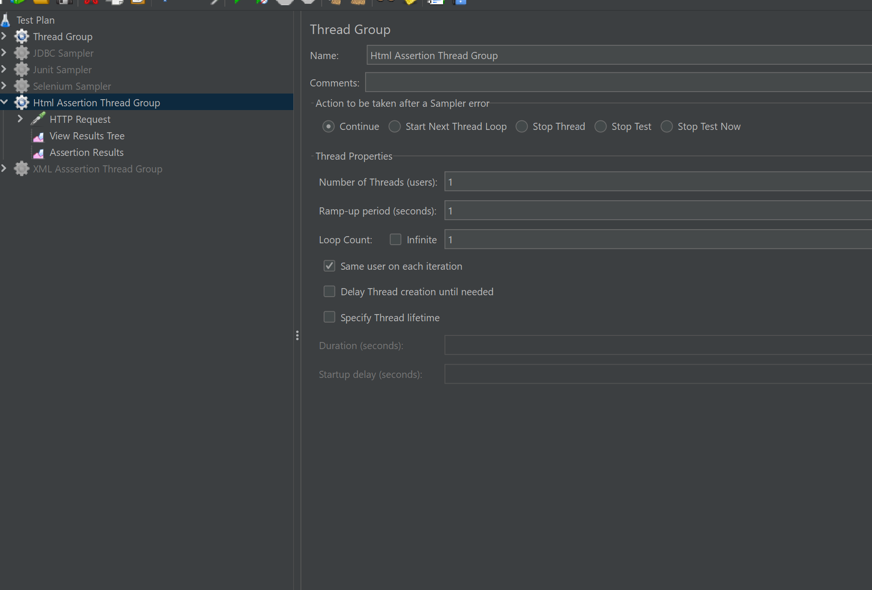

Server : blazedemo.com

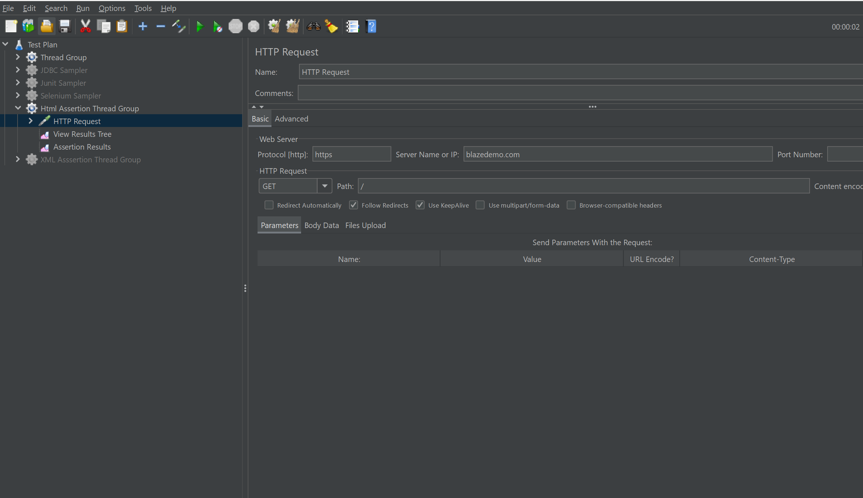

ViewResults of html:

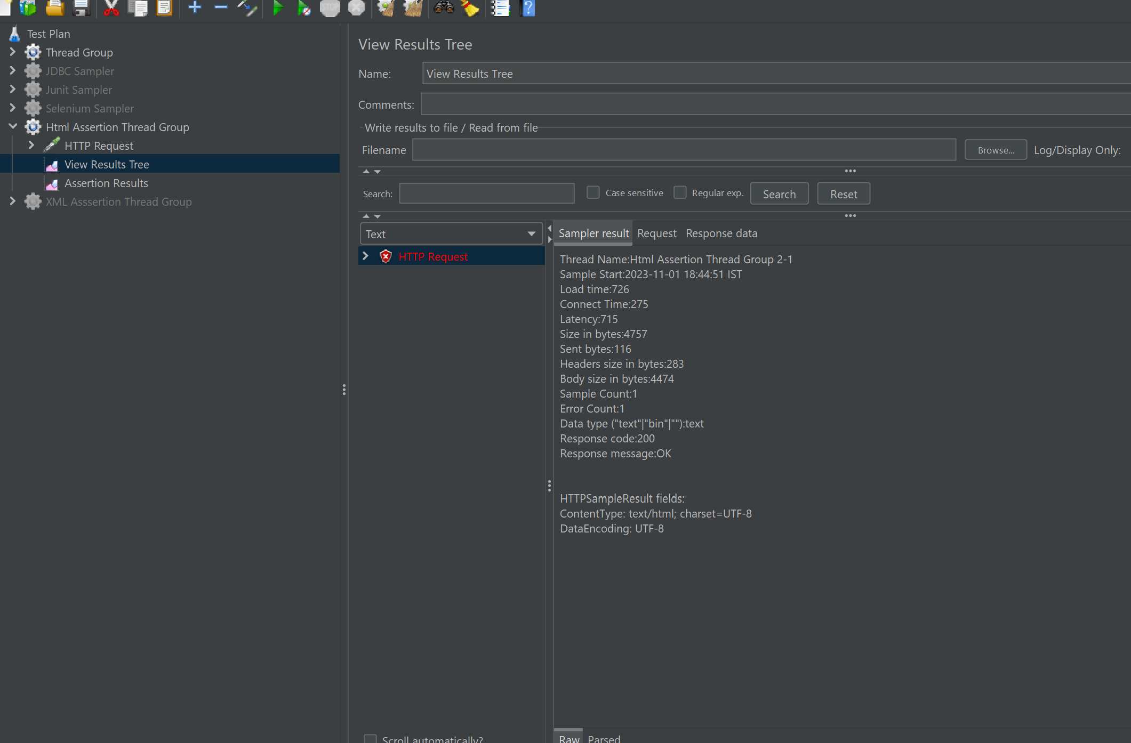

Assertions results:

